

INSTRUCTIONS for

COMPUTING GPA EQUIVALENTS USING THE GPA CALCULATORS

**Table of Contents**

OVERVIEW 2

PART 1: Download the Student Level Data Template from EZReports 2

PART 2: Sort Student Level Data Template from EZReports 5

PART 3: Identify Which Students to Include 9

PART 4: Identify Which Grading Scale Calculator(s) to Use 10

PART 5: Copy Student Records from EZReports Template into GPA Calculator 11

PART 6: Enter Student Grades into GPA Calculator 13

BASELINE GRADES (Year **prior** to reporting year) 13

CURRENT (REPORTING) YEAR’S GRADES 14

14

RESULTS: PRIOR YEAR GPA and CURRENT YEAR GPA 15

PART 7: Transfer Completed GPA Calculators to NYSED 16

Appendix A: Grading Scales 18

# 

# OVERVIEW

This document is provided to guide you through using one or more of MI’s “GPA Calculators” to convert student grades to GPA equivalents, for the purpose of reporting on **GPRA Measure 2** for students attending 21st CCLC programming in New York State.

***GPRA Measure 2:*** *Percentage of students in grades 7-8 and 10-12 attending 21st CCLC programming during the school year and summer with a “baseline or prior year” unweighted GPA of less than 3.0 who demonstrated an improved GPA during the “current year”.*

NOTES:

* New York City programs do not need to go through this process, as GPA calculators will be completed for all programs by the NYCDOE Research & Policy Support Group.
* Throughout this document, “baseline year” refers to the school or program year *preceding* the reporting year (*e.g.* if you are reporting on Program Year ending 2024, the baseline year would be 2022-23), and “current year” refers to the year you are reporting on for APR.

Before you begin this process, you will need to obtain eligible students’ report card grades from the school district, for both the baseline and current years. It is recommended that grade reports be obtained in a spreadsheet or database format to facilitate copying the information into the Calculators.

For both the baseline and current year, all GPA results must be reported based on ***converting from* *report card grades* *to GPA using the provided calculators,*** even if the school shows a GPA on the report card. This is required because the GPRA criteria may be different from the way any given school calculates GPA. GPA equivalents must be calculated for all eligible participants (eligibility is defined in Part 3), using the six-part process described below. Once GPAs are generated by the calculator, they will then be securely transferred to NYSED and your Resource Center, who will upload them back into EZReports.

# PART 1: Download the Student Level Data Template from EZReports

Use EZReports to create the **Student Level Data Template** for all students who participated during the reporting year. The Template will provide all necessary EZReports records for participants, which will be copied to the Calculator.

1. Log into EZReports for the appropriate year, at the **program (grantee) level**

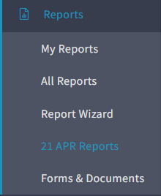

1. In the menu along the left side of the screen, click on **Reports**. A drop-down menu will appear, click on **21 APR Reports**.
2. Scroll down and click on the button titled **GPRA Data Upload.**

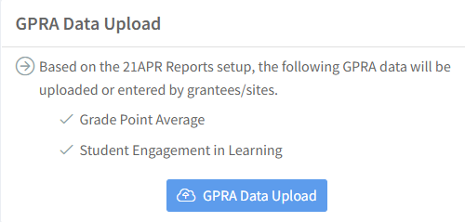

1. On the next screen, click on **Download Student Level Data Template**

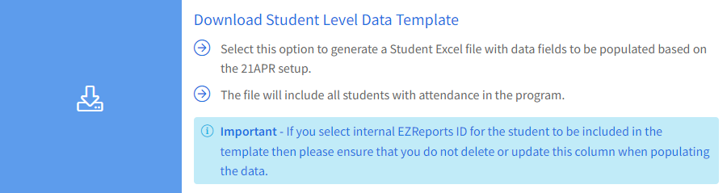

1. A screenshot of a computer

   Description automatically generatedUnder ***Please select the following columns you want to include in the student-level data template***, check and uncheck the variables as shown in the following screenshot:
2. At the bottom of the screen, click **Generate Template.**
3. Next you will see a pop-up. Click **Download Template.**
4. You should *either:*

*…*see a download status notification in the lower left of your screen. When the download is complete, click the up arrow and select ***Open*** or***Show in folder.*** Rename the excel file as desired, and save it to the desired file location.

…*or,* you will see a Save As pop-up window. When the download is complete, select the desired location, rename the excel file as desired, and click ***Save.***.

1. Open the saved **Student Level Data Template** Excel file.

# PART 2: Sort Student Level Data Template from EZReports

1. Delete the **sub-header row** (Row 2), as follows:
   1. Right Click on **Cell A2,** and select **Delete** from the pop-up menu.

* 1. When the next pop-up appears, select **Entire Row**, and click **OK.**Graphical user interface, text, application

     Description automatically generated

1. Sort students by grade level and delete all students who are not in grades 7, 8, 10, 11 or 12. *(If you do not need instructions on how to do this in Excel, skip to* ***Step #15****.)*
2. a) Left Click on **Cell A1** *(Last Name)*.

b) In the top menu bar, click on the **Data** tab.

c) In the **Sort & Filter** section, click **Sort.**

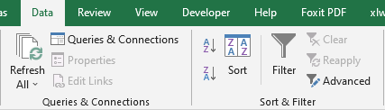

1. In the **Sort** window pop-up, make sure the **My data has headers** check box is checked. Under **Column**, select “Grade Level Code (2022-2023)” from the *Sort by* drop-down list, and click **OK.**

If a “Sort Warning” pop-up window appears, select *Sort anything that looks like a number, as a number* and click **OK**. Then **Save** the file.

1. Next, we want to delete the rows with students in grades that do not need to be entered (*i.e.,* grades PK through 6 and grade 9.)
   1. Select any rows with students in grades PK through 6 or grade 9. *(To select multiple rows, left click on first row # to delete, hold the left click button and drag to the last row).*
   2. Once the rows to be deleted are selected, right click, and select **Delete.**
   3. When the next pop-up appears, select **Entire Row**, and click **OK.**

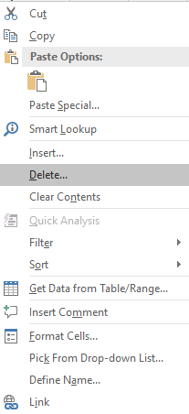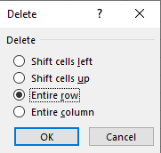

1. **If any of your students already have values entered for GPA, delete the values –** these may be GPA scores assigned by the district, which we cannot use**.** (Do not delete the column or the column headers.)

1. **If your program data contains multiple districts, schools and/or grades that use different grading scales**, you will need to use different calculators for each scale (see Part 4). If so, re-sort the remaining students by *District, School*, and/or G*rade* as explained in the next step; otherwise skip to Part 3.
2. [Same as Step 12]

a) Left Click on **Cell A1** *(Last Name).*

b) In the top menu bar, click on the **Data** tab.

c) In the **Sort & Filter** section, click **Sort.**



1. Again, make sure that “*My data has headers*” is checked, and specify the variables you want to sort by. If you wish to sort by more than one variable, use the **Add Level** button within the **Sort** window. When sorting by more than one variable, always sort by the more general variable first (*e.g.,* sort by District by School, *not* by School by District). For example, it may be helpful to sort by District, then School, then Grade Level. In the screenshot below, the more general sort variables should appear above the more specific variables.

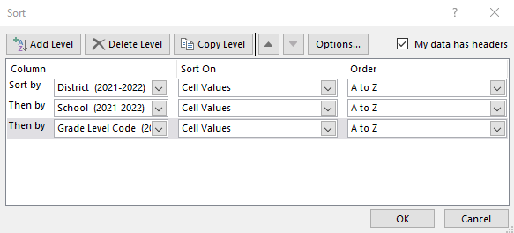

1. When sorting is complete, **Save your file.**

# PART 3: Identify Which Students to Include

Students that should be entered into the GPA Calculator are those who meet *all* of the following criteria:

* Were **in grade 7, 8, 10, 11 or 12** during the ***reporting*** school year.
* **Attended the same school** in prior year **and** current year
* **Have available report card grades** for **both** the prior year and current year
* Attended a school that used the **same grading system both years** for the grade levels that the student was enrolled in
* **Attended a school that used one of the 14 grading scales (Appendix A)** for which a GPA Calculator has been developed (see next section)
* Had an ***official* (school-reported) overall GPA < 3.0** from the prior year, **or****no official prior year GPA** was reported by the school

If there are schools, or individual students who do not meet all of these criteria, ***you do not need to enter these students into the GPA Calculator*** *– just skip them* when entering the grades.

# PART 4: Identify Which Grading Scale Calculator(s) to Use

To reflect the wide range of grading scales used by schools across the state, we have identified 14 of the most commonly used scales (Appendix A), and created a separate GPA Calculator for each scale[1]. Each Calculator uses a unique crosswalk that aligns the course grades for each grading scale to corresponding GPA scores.

If all of your students come from schools and grade levels that use the same grading scale (during both the prior [baseline] and current [reporting] year), then you are welcome to enter them into a single GPA calculator file.

However, if any of your program’s students come from schools or grade levels that use different grading scales, you will need to separate or group the student data by school/grade and enter their course grades into different GPA calculator files. Note that each student would still need to have been graded on the *same* scale during the baseline and reporting years.

Before you begin entering data, please review the scales and associated calculators (see Appendix A), and **identify the scale(s) that *exactly* match the grading scale(s) used by the school and grade level(s)** for which you are entering data. (For example, if the school uses letter grades with +’s and –‘s but does not include D+ or D-, you should use Scale 1, not Scale 2.)

NOTE: For students who were graded on one of the percentage scales (0-100%, with a passing cut-off of either 65% or 55%), there are two alternate calculators for each scale: Scales 10a and 11a require entering the range within which a student’s grade falls, while 10b and 11b require entering the student’s exact grade.

*If the grading scale used for any of your student groups is not reflected among the options in Appendix A, do not report GPAs for this group of students. Move on to the next school or grade level (if applicable) and repeat the above step.* **Please notify your Resource Center so that MI can create a new calculator to accommodate this grading scale in future years.**

Once you have identified the correct grading scale(s), **select** **the GPA Calculator Excel file that corresponds with the grading scale for the first group of students you will enter**.

# PART 5: Copy Student Records from EZReports Template into GPA Calculator

1. **Open the appropriate GPA Calculator** 
   1. If you see a message at the top of the file such as the following, click on **Enable Editing**:

* 1. **Rename and save the file** to reflect the group of students you are about to enter, **using the following naming convention**:

|  |
| --- |
| ***Calculator Scale [X]–GrantNum [xxxx] – [SchoolName(s)] – Grade(s) [x-y] – Pgm Yr yyyy-yy.xlsx*** |

(For example, “*Calculator Scale 1 – GrantNum 8999 – PSMS22 & Abner MS - Grades 7-8.Pgm Yr 2022-23.xlsx*”.)

**IMPORTANT:** As of spring 2024, we are using a new system to securely transfer confidential records, that you will use to send completed calculators to your TARC. This system does not permit file names to include certain special characters. Instructions are provided below on sending your files, including dealing with file name violations.

1. Copy all rows from the *EZReports* ***Student Level Data Template*** for those students you will be entering into this Calculator, and **Paste-VALUES in Cell A5** of the GPA Calculator’s “**Baseline Grades**” tab, as explained below*.*

*(If you do not need instructions on how to do this in Excel, skip to PART 6 after pasting.)*

* 1. In the *EZReports Student Level Data Template* that you previously sorted, left-click in Column A in the first row of student data that you want to select (*e.g.* **Cell A2**). While holding down the left-click button, drag your cursor to select all the data from **Column A** (*Last Name*) to **Column H** (*Grade Level Code (2022-2023)*), and from the first row down to the last row of student data that you want to select. Do not select the blank GPA columns (Columns I and J).

* 1. Once the data is selected, copy it by either using the shortcut **Ctrl**+**C**, or go to the top menu bar **Home** tab and under **Clipboard** click on the **Copy** icon.

|  |  |
| --- | --- |
| * 1. In the GPA Calculator, click on the **Baseline Grades** **tab.** | * 1. Click on **Cell A5 (under Last Name)** to paste the data from the EZR Template by using **Paste Values**, as follows: |

* + 1. Go to the top menu bar **Home** tab, click on the small arrow under **Paste**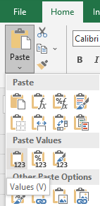
    2. From the drop-down menu click on the first icon under **Paste Values**.

# PART 6: Enter Student Grades into GPA Calculator

## BASELINE GRADES (Year **prior** to reporting year)

1. Chart

   Description automatically generatedFor each student, enter the final course grade from the **prior school year**, for any course that falls under one of the four subject areas (**Math, Science, Social Studies, and English**). The grade values for the scale you have chosen will appear in a drop-down menu in each cell. You can select a value from the drop-down, copy and paste it from the student’s report card, or just type it into the cell.

*If you get an error message when you type a course grade, it means you are typing a value that is not part of that Calculator.* You should skip entering any courses that are on a different grading scale.

* 1. Select, paste or type the final grade for *all* courses that fall under any of the four subject areas. There is space to enter grades for up to 5 courses per subject. Skip any courses that were graded on a different scale than the others (most often Pass/Fail, for example).
  2. **If a student does not have any courses in one of these four subjects**, or if the only gradesin a subject **are on a different scale** (such as Pass/Fail), just leave that subject blank and enter grades for the other subjects.
  3. **Enter the final grade for each course in a separate cell**, no matter if it represents a full-year course or a half-year course.

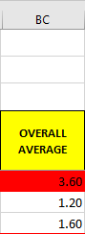

1. The **Baseline Year** GPA for each student will be calculated automatically in **Column BC**. If the **baseline year** GPA for a student is 3.0 or greater, it will show as red. This indicates that you **do not** need to enter the current year grades for that student in the Current Year Grades tab. Any student with a prior year GPA of 3.0 or greater (*as determined by the calculator –* even if any school-provided GPA is different) is to be excluded from the GPA reporting.

## CURRENT (REPORTING) YEAR’S GRADES

1. On the **CURRENT YEAR GRADES** tab, you will not need to re-enter any student information (name, DOB, ID codes, *etc.*) as it will appear automatically based on what you entered in the **Baseline Grades** tab. Table

   Description automatically generated
2. Column I will again remind you whether or not you need to enter the **Current Year** grades for that student. If the student’s *calculated* prior year GPA is 3.0 or greater, you do not need to enter the **Current Year** grades (the cell will show SKIP in red). Any student with a prior year GPA of 3.0 or greater (as determined by the calculator) is to be excluded from the GPA reporting. This is true even if that student had an *official* (school-reported) prior year GPA below 3.0 (*i.e.,* calculator GPAs take precedence). This column will also appear as SKIP if no Baseline Grades have been entered.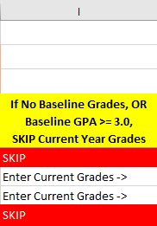
3. For each student *who did not have a Baseline Grade of 3.0 or higher* (Column I will show “Enter Current Grades ->”), select, paste or type their final grade for the **current school year (reporting year)** for any course that falls under one of the four subject areas (Math, Science, Social Studies, and English), using the same approach as for theprior year grades in the *Baseline Grades* tab.

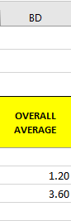

1. The **current year** GPA for each student will be calculated automatically in **Column BD**. Note that students for whom you did not enter Current Year Grades, because they had a Baseline Grade at or above 3.0, will have a blank cell in this column.

## RESULTS: PRIOR YEAR GPA and CURRENT YEAR GPA

1. A screenshot of a computer screen

   Description automatically generatedThe **RESULTS** tab will display the prior year and current GPA calculated for each student.

1. **Save all changes** to the file that you renamed at the beginning of Part 5

|  |
| --- |
| **Reminder: If you have other groups of students graded on different scales**  **select the GPA Calculator file corresponding to the appropriate grading scale for the next group and repeat Part 5 and Part 6 steps.** |

# 

# PART 7: Transfer Completed GPA Calculators to NYSED

Once you have completed all of your Calculators, you will need to securely upload them to NYSED’s SharePoint site. Note that *you do not need to upload the Calculator files back to EZReports* – this will be done by the Resource Centers and NYSED staff.

Your Program Director should be receiving an email shortly from EMSC with instructions on how to upload your completed Calculators.

If you did not receive this email or need assistance with the upload, reach out to Nicholas Canino at [Nicholas.Canino@nysed.gov](mailto:Nicholas.Canino@nysed.gov) for assistance.

# Appendix A: Grading Scales

|  |  |  |  |  |  |  |  |  |  |  |  |  |  |  |
| --- | --- | --- | --- | --- | --- | --- | --- | --- | --- | --- | --- | --- | --- | --- |
| **SCALE 1** |  | **SCALE 2** | | |  | **SCALE 3** |  | **SCALE 4** | |  | | **SCALE 5** | | |
| A+ |  | A+ | | |  | A |  | Exceeding Expectations | |  | | Exceeds Standards | | |
| A |  | A | | |  | B |  | Above Expectations | |  | | Meets Standards | | |
| A- |  | A- | | |  | C |  | At Expectations | |  | | Working Toward Grade  Level Standard | | |
| B+ |  | B+ | | |  | D |  | Below Expectations | |  | |
| B |  | B | | |  | F |  | [Failing] | |  | | Unable To Meet Grade  Level Standard | | |
| B- |  | B- | | |  |  |  |  | |  | |
| C+ |  | C+ | | |  |  |  |  | |  | | [Failing] | | |
| C |  | C | | |  |  |  |  | |  | |  | | |
| C- |  | C- | | |  |  |  |  | |  | |  | | |
| D |  | D+ | | |  |  |  |  | |  | |  | | |
| F |  | D | | |  |  |  |  | |  | |  | | |
|  |  | D- | | |  |  |  |  | |  | |  | | |
|  |  | F | | |  |  |  |  | |  | |  | | |
|  |  |  | | |  |  |  |  | |  | |  | | |
| **SCALE 6** | | |  | **SCALE 7** | | | |  | **SCALE 8** | |  | | **SCALE 9** |
| Excellent | | |  | Excellent | | | |  | Excelling | |  | | 4 |
| Good | | |  | Good | | | |  | Proficient | |  | | 3 |
| Satisfactory | | |  | Improving | | | |  | Partially proficient | |  | | 2 |
| Unsatisfactory | | |  | Needs Improvement | | | |  | Well below proficient | |  | | 1 |
| [Failing] | | |  | [Failing] | | | |  |  | |  | | 0 |

|  |  |  |  |  |  |  |  |  |
| --- | --- | --- | --- | --- | --- | --- | --- | --- |
| **SCALE 10a** |  | **SCALE 10b**  **(numeric)** |  | **SCALE 11a** |  | **SCALE 11b**  **(numeric)** |  | **SCALE 12** |
| 97-100% |  | 100% |  | 95-100% |  | 100% |  | 9 |
| 93-96% |  | to |  | 91-94% |  | to |  | 8 |
| 90-92% |  | 65% |  | 87-90% |  | 55% |  | 7 |
| 87-89% |  | Below 65%  (Failing) |  | 85-89% |  | Below 55%  (Failing) |  | 6 |
| 83-86% |  |  |  | 81-84% |  |  |  | 5 |
| 80-82% |  |  |  | 76-80% |  |  |  | 4 |
| 77-79% |  |  |  | 71-75% |  |  |  | 3 |
| 73-76% |  |  |  | 66-70% |  |  |  | 2 |
| 70-72% |  |  |  | 61-65% |  |  |  | 1 |
| 67-69% |  |  |  | 57-60% |  |  |  |  |
| 65-66% |  |  |  | 55-56% |  |  |  |  |
| Below 65%  (Failing) |  |  |  | Below 55%  (Failing) |  |  |  |  |

|  |  |  |
| --- | --- | --- |
| **SCALE 13** |  | **SCALE 14** |
| Excellent |  | 3 |
| Satisfactory |  | 2 |
| Needs Improvement |  | 1 |
|  |  |  |
|  |  |  |
|  |  |  |
|  |  |  |
|  |  |  |
|  |  |  |

1. There are two alternate calculators for each of the two percentage grade scales, for a total of 16 calculators.